ET 541 Electronic Devices, 4 Credits

UNH Credit Hour Policy: The University of New Hampshire is in compliance with the federal definition of the credit hour. For each credit hour, the university requires, at a minimum, the equivalent of three hours of student academic work each week assuming a 15-week semester (student workload for shorter length terms must be increased proportionally per week to maintain required approximately 45 hours of work per credit per term). Student work reflects intended learning outcomes and is verified through evidence of student achievement. For this 4-credit, 15-week course, students are expected to spend a minimum of 12 hours each week on their academic work.

Attributes: NONE

CLASS MEETING INFO: (fictious day and time slots)
Section | Day | Start Time | End Time | Room
Lecture | Tuesday/Thursdays | 10:10 AM | 11:30 AM | P102

Course Description:

Introductory course in Electronic devices looking at modern components used in current electronic systems. This course will develop techniques to analyze basic semiconductor devices such as diodes, field effect transistors and bipolar transistors. Specific diode circuits covered include, rectifying, clipping, and clamping diode circuit. Methods to model and bias the basic transistor amplification circuits will also be developed.

REQUIRED TEXT:
Electronic Devices (10th Edition)  Thomas L. Floyd  ISBN: 978-0-134414447 | 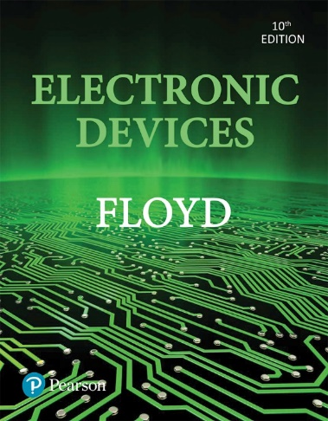

INSTRUCTOR: Donald Marcotte (Adjunct professor)
e-mail: Donald.Marcotte@unh.edu

OFFICE HOURS: Arranged by appointment.

Christopher LeBlanc Office: P107
UNHM Phone: 603-641-4323
e-mail: Christopher.LeBlanc@unh.edu

GRADING: The grading for this course will be divided among the following categories:
Homework 40%
Tests (2) 40%
Final Exam 20%

Spreading the overall course grade across different assessment methods is helpful for most students who may have difficulty with one method, e.g. test anxiety, time constraint, etc. It is important that the student complete assignments in each of the above categories in order to achieve a passing grade in this course.

If you have questions during the semester, please feel free to ask the instructor. If you are having trouble understanding the material or with the course, please let the instructor know as early as possible.

ASSIGNMENTS: Homework and activity/exercise assignments will be assigned throughout the semester. All assignment information will be posted on Canvas with applicable due dates. Typically, a two-week advance notice for a test will be given. All assignments must be submitted by the due date. Late assignments will be accepted up to “ONE-WEEK” (5 weekdays) beyond the announced due date. Late assignments will be reduced one full letter grade. Late assignments submitted after the “ONE-WEEK” period will not be accepted and a grade of “zero” will be recorded for that assignment. Tentative dates for tests are indicated on the course outline. Watch for update/revisions to course outline schedule and announcements in Canvas. The schedule will change over the course of the semester.

ASSIGNMENT SUBMISSION REQUIREMENTS: General requirements for assignments, as well as tests, and final project:

- Always show all your work. (No partial credit can be given unless steps are clearly shown.)
- Clearly identify final answers.
- Work should be legible and performed in a clear, organized manner.
- Turn in homework in electronic form. Electronic form should consist of a single coherent legible document for each single assignment. Do not submit several pieces of electronic items such as phone snapshots for a given single assignment. Scanning may be done using the ET Commons copier/printer.
- Include a cover page with assignment information on each assignment submitted. This includes the assignment number and type of assignment, e.g. Homework #1 Chapter 1, Activity 1 – Brainstorming Exercise. Be sure to include your name (and names of your group if applicable) on the cover page.
- Some assignment formats may vary per activity/exercise.

These items facilitate fair grading of the assignment and granting of partial credit where warranted. Working on homework and activity assignments in groups is permitted but each person will submit individual assignments when required. Activity assignments may be individual or by group depending on the exercise and requested format.

ATTENDANCE: The University absent policy is found in the handbook at this website address:
https://catalog.unh.edu/srrr/academic-policies/attendance-class-requirements/ Students are responsible for all material covered in class and posted on Canvas. Regular class attendance and participation in discussions is strongly encouraged and expected.

Tests, Lab reports and Final exam: Tests will typically take ½ to 1 hour of class time. (If circumstances dictate, part of a test may be given in a Take Home format.) If a student needs to miss a test for any reason, the instructor should be notified prior to the session in which it is given. In extreme circumstances and if no prior notification is possible, the student must contact the instructor within 24 hours of the missed test and submit a valid reason why the test was missed. A modified test may be given on a case-by-case basis. See the Student with Disabilities section if modified exams are required.

ACADEMIC HONESTY: In the preparation and presentation of any assigned work – including examinations, tests, quizzes, term papers, reports, papers and other written or oral exercises – every student shall conform to a strict standard of academic honesty. Any attempt to deceive a faculty member or to help another student to do so will be considered a violation of this standard. In all assignments, students must acknowledge the words and/or ideas of others taken from print or electronic media, whether a direct quotation or a paraphrase; any omission of this is dishonest. Cheating on examinations or tests consists of knowingly giving, receiving, or using – or attempting to give, receive, or use – unauthorized assistance during an examination or test. A faculty member may record a grade of “zero” for any assignment on which a student has plagiarized or cheated. For repeat offenses within a single course, the faculty member may record a grade of “F” for the course. Violations of this policy in multiple courses may result in dismissal from the college. See these various links to academic honesty, plagiarism tutorial, and academic integrity:

https://catalog.unh.edu/srrr/academic-policies/academic-honesty/
https://cola.unh.edu/academics/plagiarism-tutorial
https://catalog.unh.edu/srrr/university-policies-regulations/academic-integrity/

STUDENTS WITH DISABILITIES (2022): Accessibility Services – Manchester
The University is committed to providing students with documented disabilities equal access to all university programs and facilities. If you think you have a disability requiring accommodation, you must register with the Student Accessibility Services (SAS) office. Please contact Student Accessibility Services (SAS) located on the Manchester campus in the Student Services Suite (Office 405A).

Accommodation letters are created by our Coordinator with the student. Please follow up with your instructor as soon as possible to ensure timely implementation of the identified accommodations in the letter. Faculty have an obligation to respond once they receive official notice of identified accommodations but are under no obligation to provide retroactive accommodations.
For more information refer to www.unh.edu/sas or contact SAS at 603.862.2607, 711 (Relay NH) or sas.office@unh.edu.

Confidentiality and Mandatory Reporting of Sexual Violence or Harassment:
The University of New Hampshire at Manchester and its community are committed to assuring a safe and productive educational environment for all students. Title IX makes it clear that violence, harassment, and discrimination based on sex and gender are Civil Rights offenses subject to the same kinds of accountability and the same kinds of support applied to offenses against other protected categories such as race, national origin, and ability.

If you or someone you know has experienced sexual or relationship violence, and/or stalking and harassment, you can find the appropriate resources below:

Reporting On Campus:
- Title IX Deputy Intake Coordinator: Lisa Enright 603-641-4336. Lisa’s office is located on the fourth floor in Room 439.
- UNH Manchester Security: 603-641-4124 or located in the second-floor foyer
Reporting Off Campus:
- Manchester Police Department - 603-668-8711, 405 Valley St. Manchester, NH
- or your local police department

For emergencies dial 911.

Confidential Support Resources:
- YWCA, NH – 603-668-2299(24hour), 72 Concord St. Manchester, NH
- Sexual Harassment and Rape Prevention Program (SHARPP): 603-862-7233(24hour), 8 Ballard Street, Wolff House, Durham NH 03824
- The Mental Health Center of Greater Manchester: See contact information and hours above.
- 24 Hour NH Sexual Violence Hotline: 1-800-277-5570
- 24 Hour NH Domestic Violence Hotline: 1-866-644-3574

UNH Statement on emotional or mental health distress: In partnership with The Mental Health Center of Greater Manchester, UNH Manchester offers consultation visits on a walk-in basis and through telehealth appointments.

Services include:
- Free confidential screening & consultation with a licensed mental health therapist.
- Referrals to mental health or substance misuse treatment.
- And assistance in understanding how to afford additional treatment (with or without insurance!) or find free services.

You may email: unhm.wellness@unh.edu to make an appointment to meet with a counselor by clicking here or by using the QR codes below.

For in person appointments please scan this code
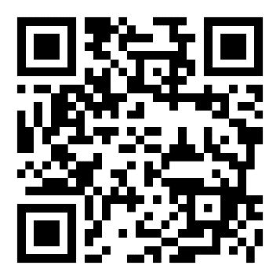
For remote appointments please scan this code
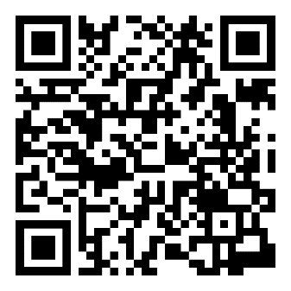

If you would like to connect to counseling services directly, you may do so by contacting The Greater Manchester Mental Health Center at (603) 668 - 4111. If you or someone you know is experiencing a mental health or substance misuse crisis, please contact the Mobile Crisis Response Team (MCRT) at (800) 688 - 3544.

The National Suicide Prevention Lifeline provides 24/7, free and confidential support via phone or chat for people in distress, resources for you or your loved ones, and best practices for professionals. Call (800) 273-TALK (8255).

ABET/ETAC (Accreditation Board for Engineering and Technology/Engineering Technology Accreditation Commission)

I. General Criteria (2020)

Criterion 3. Student Outcomes
The program must have documented student outcomes with a documented and effective process for the periodic review and revision of these student outcomes.
For purposes of this section, well-defined activities or problems are practical, narrow in scope, use conventional processes and materials in traditional ways, and require knowledge of standard operating processes. Broadly defined activities or problems are practical, broad in scope, relatively complex, and involve a variety of resources; use new processes, materials, or techniques in innovative ways; and may require extension of standard operating procedures.

B. For baccalaureate degree programs, these student outcomes must include, but are not limited to, the following:

- an ability to apply knowledge, techniques, skills and modern tools of mathematics, science, engineering, and technology to solve broadly defined engineering problems appropriate to the discipline;

- an ability to design systems, components, or processes meeting specified needs for broadly defined engineering problems appropriate to the discipline;

- an ability to apply written, oral, and graphical communication in broadly defined technical and non-technical environments; and an ability to identify and use appropriate technical literature;

- an ability to conduct standard tests, measurements, and experiments and to analyze and interpret the results to improve processes; and

- an ability to function effectively as a member as well as a leader on technical teams.

II. PROGRAM CRITERIA

Discipline Specific Educational Outcomes
Electrical Engineering Technology
Lead Society: Institute of Electrical and Electronics Engineers
The UNH-M Electrical Technology program will prepare graduates with the skills necessary to enter careers in the design, application, installation, manufacturing, operation and/or maintenance of electrical/electronic(s) systems.
EET Outcomes
- The application of circuit analysis and design, computer programming, associated software, analog and digital electronics, and microcomputers, and engineering standards to the building, testing, operation, and maintenance of electrical/electronic(s) systems; and
- The application of natural sciences and mathematics at or above the level of algebra and trigonometry to the building, testing, operation, and maintenance of electrical/electronic systems.
- The ability to analyze, design, and implement one or more of the following: control systems, instrumentation systems, communications systems, computer systems, or power systems.
- The ability to apply project management techniques to electrical/electronic(s) systems; and
- The ability to utilize differential and integral calculus, as a minimum, to characterize the performance of electrical/electronic systems.

